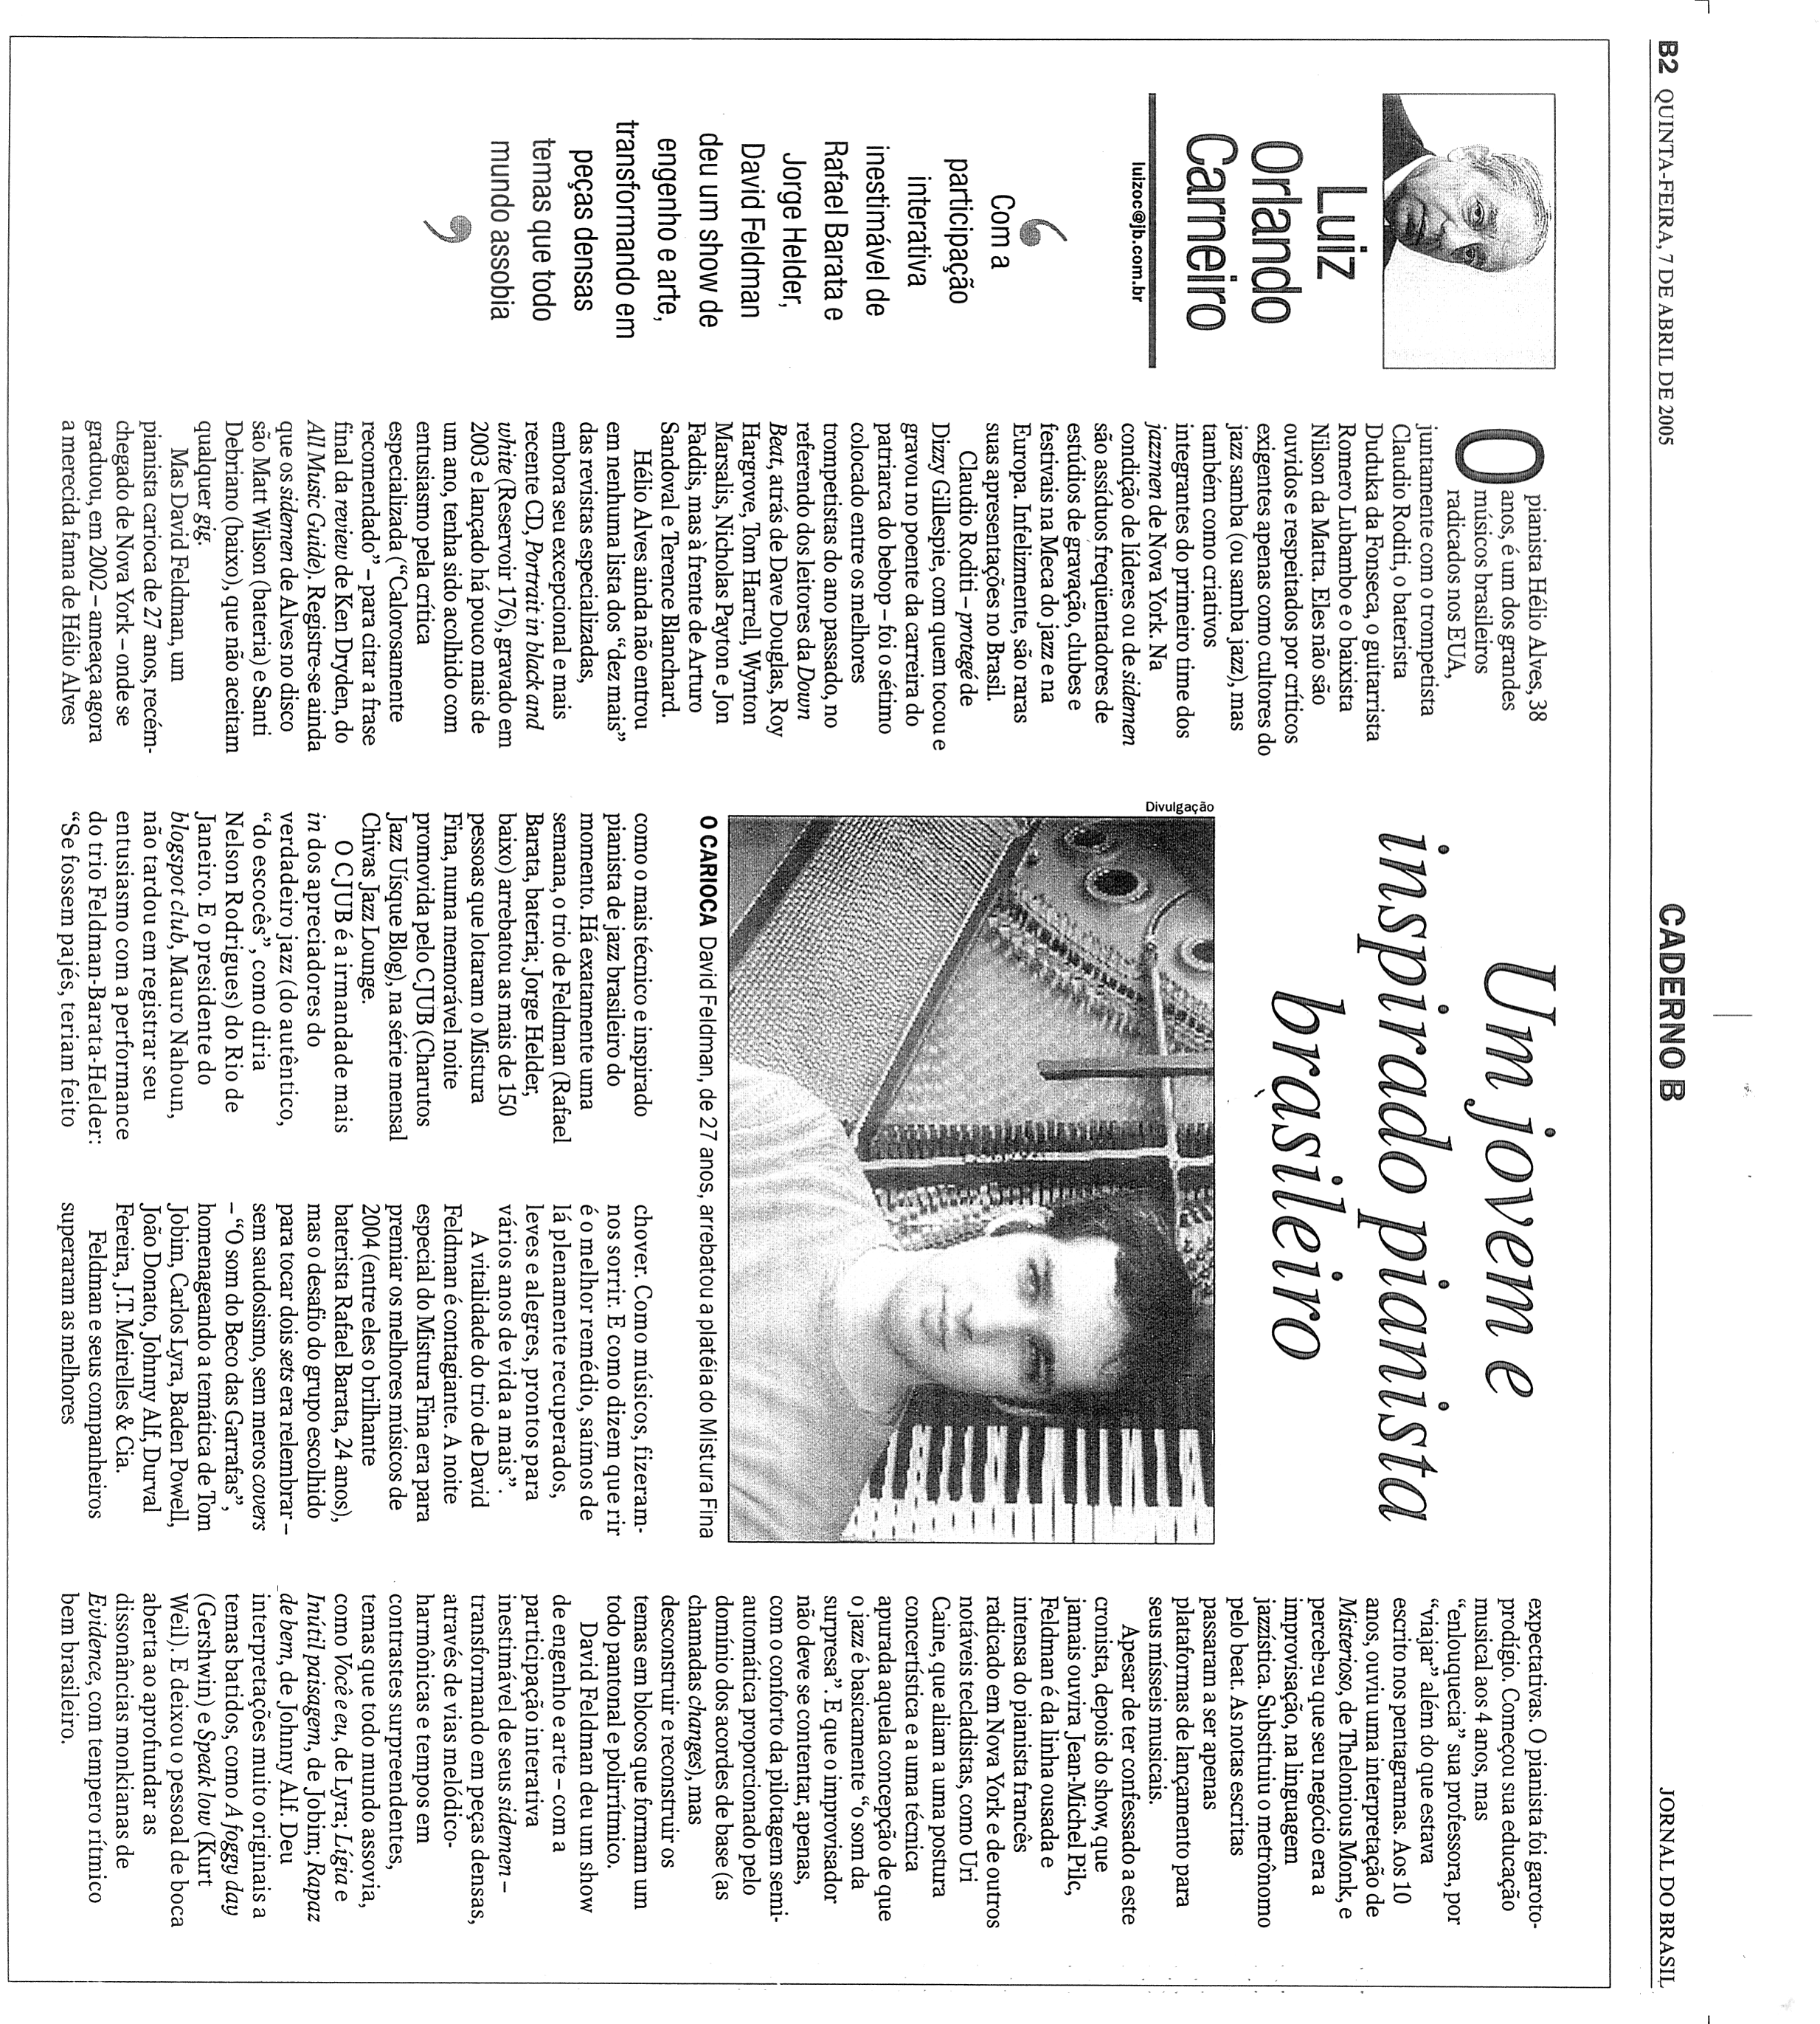

THE SOUND OF “BECO DAS GARRAFAS”
Homage to the generation that turned Brazilian music upside-down

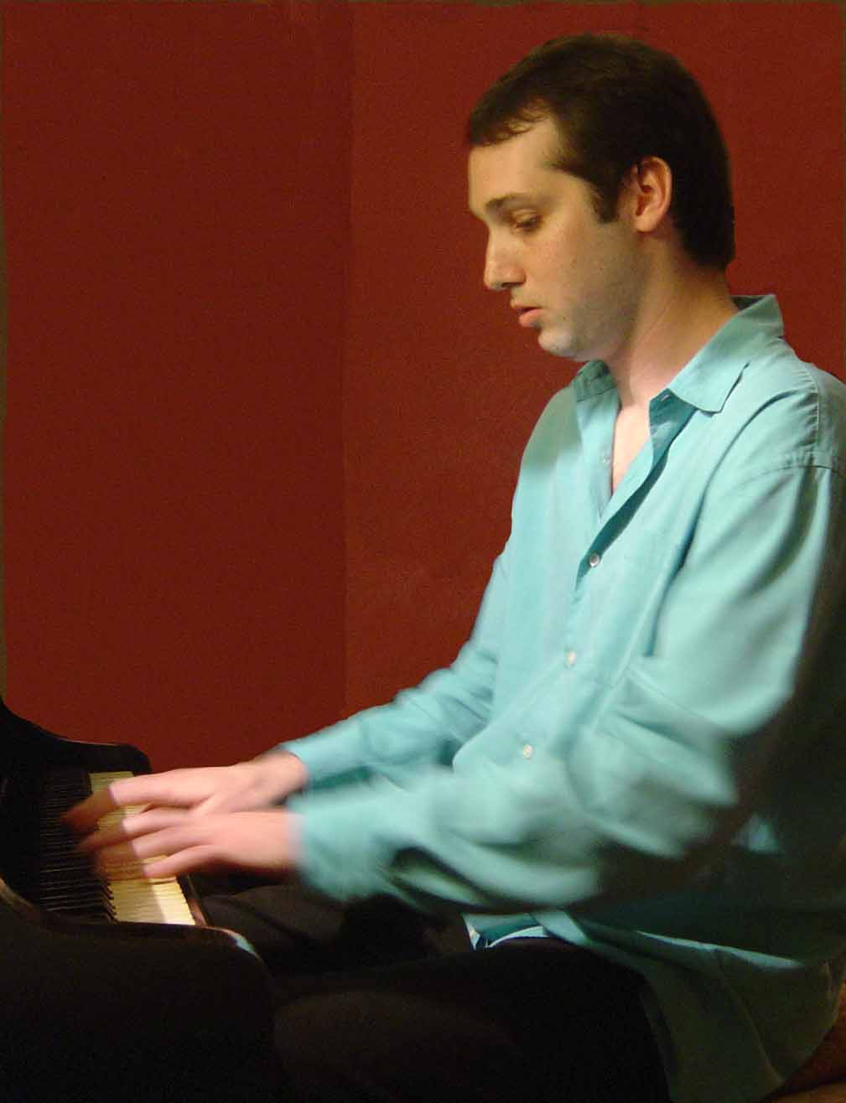

DAVID FELDMAN TRIO
David Feldman - piano
Sérgio Barrozo - bass
Paulo Braga – drums
foto: Teresa Sequerra

Pianist who plays with renowned musicians like Paulo Moura, Claudio Roditi, Leila Pinheiro and Leo Gandelman,, young carioca David Feldman, acclaimed by the jazz critics, presents the concert "The Sound of the Beco das Garrafas"

The David Feldman Trio is formed by high-caliber instrumentalists, Sérgio Barrozo on acoustic bass and Paulo Braga on drums. The repertoire includes Brazilian known themes like Rapaz de Bem by Johnny Alf, Sambou Sambou by João Donato, Tristeza de Nós Dois by Maurício Einhorn, Brigas Nunca Mais by Tom Jobim, besides his original composition The Sound of “Beco das Garrafas, spiced with lots of samba-jazz.

Semi-finalist in 2004 on the prestigious Montreux Jazz Solo Piano Competition, David Feldman, who lived outside Brazil for the last twelve years, says that he learned to value Brazilian music abroad. “Jazz musicians from all over the world are enchanted with our sound, our rhythm, and with the great instrumentalists that Brazil generated ”. He continues “ I want to homage the Beco generation because in my opinion many times they didn’t get the deserved recognition in Brazil.

THE HOMAGE
I wasn’t even born when the Beco was a todo vapor but, still when I was a child, listening to records and stories of who had been there, - I was a student of the iniguálavel Luiz Eça – I started to have a desire for having a time machine.
This concert is my private time machine, a homage to this generation of fantastic musicians that influenced me so much and who put brazilian music into the international map.
I looked into having in the repertoire themes that were frequently played at the Beco. On the concert, we will have aside of classic themes of Bossa Nova and samba jazz like Você e eu by Carlos Lyra, Só por amor by Baden Powell, Inútil Paisagem by Tom Jobim, São Salvador by Durval Ferreira and Quintessência by J.T. Meirelles, jazz standards like Evidence by Thelonius Monk and A Foggy Day by Gershwin turbinados com a cadência do Beco.

David Feldman

Beco das Garrafas (Bottle’s Dead End)

Beco das Garrafas was named after a dead-end formed by three nightclubs in Copacabana, where the musicians had the liberty to play what they wanted. This freedom was the fertile ground for a creative effervescence with no precedents. Samba-jazz was born there, fusion between samba and jazz, which conquered the world. According to one of its habitués, the critic José Domingos Raffaelli" ...the Beco das Garrafas was the carioca equivalent of the more than legendary 52nd st, in New York, where jazz sparkled on the 40s e 50s..... The regulars say that every night something new happened, was it a new composition, a new musician coming up or the formation of a new band. It was the great renewal of Brazilian music started to get a worldwide attention in 1961/62".
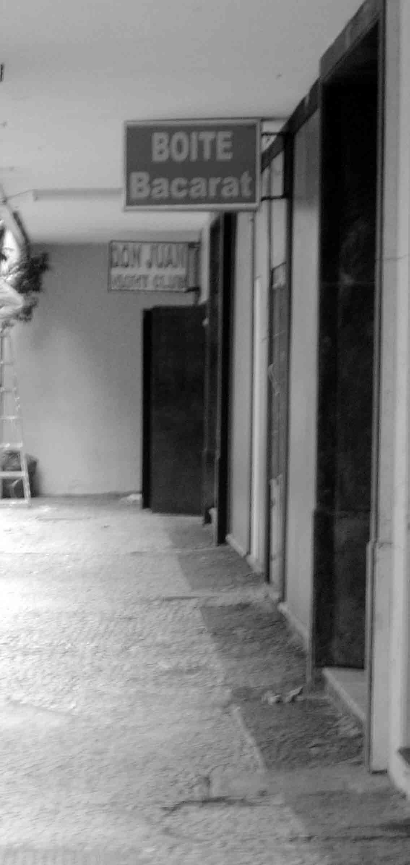
Beco das Garrafas -2005

Among the musicians that made part of Beco das Garrafas (in alfabetical order) are: Alberto Castilho, Alfredo de Paula, Aurino Ferreira, Baden Powell, Bebeto, Bill Horn, Celso Brando, os irmãos Castro Neves, Chico Batera, Cipó, Dom Salvador, Dom Um Romão, Durval Ferreira, Ed Lincoln, Edison Machado, Edison Maciel, Edmundo Maciel, Edson Lobo, Eumir Deodato, Flora Purim, Hamilton, Hélcio Milito, Hélio Marinho, J.T.Meirelles, Juarez Araújo, João Luiz Maciel, João Palma, Johnny Alf, Jorginho Ferreira da Silva, Julio Barbosa, Leny Andrade, Lindolfo Gaia, Luís Carlos Vinhas, Luis Marinho, Luiz Eça, Manuel Gusmão, Maurício Einhorn, Maurílio, Milton Banana, Moacir Marques, Moacir Santos, Otávio Bailly, Ohana, Paulo Moura, Pedro Paulo, Raul de Souza, Roberto Menescal, Rafael, Rildo Hora, Ronaldo Vilela, Ronie Mesquita, Rosinha de Valença, Rubens Bassini, Sérgio Barroso, Sérgio Mendes, Silvinha Telles, Tenório Jr, Tião Neto, Tião Marinho, Toninho, Ugo Marota, Vitor Assis Brasil, Vitor Manga, Wilson das Neves, Zezinho Alves and so many talents that wouldn’t fit in one night.
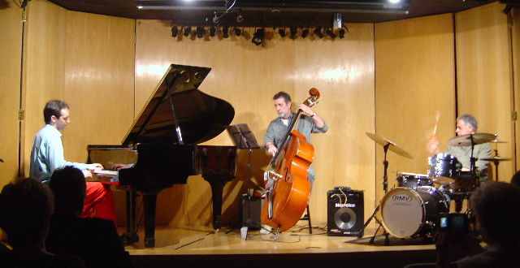

DAVID FELDMAN TRIO
Sérgio Barrozo - bass
David Feldman - piano
Paulo Braga - drums

DAVID FELDMAN – PIANO

Thirty-one-year-old David Feldman was born in Rio de Janeiro, Brazil, the cradle of Samba and Bossa Nova. Born in a family of classical and early-music musicians he started very early his musical studies, playing classical piano at the age of four. David would drive his piano teacher crazy, because he would never stick to what was written on the music sheet. When, at the age of ten, he heard Thelonius Monk’s “Misterioso” it became obvious that he should be playing jazz.
In 2002, David fulfilled his childhood dream and moved to NYC. He enrolled at the New School Jazz and Contemporary Music Program where he graduated in 2002. In such a short period time, he already worked with legends of jazz like Slide Hampton and Claudio Roditi; was invited to sit in the Mingus Big Band; worked with 2003 Grammy nominee Duduka da Fonseca and with brilliant young musicians like Matt Garrison and Eli de Gibri. He also plays regularly in duos with Paulo Moura and Leo Gandelman.

SÉRGIO BARROZO – BASS

Grandson of pianist and composer Joaquim Antonio Barrozo Netto, Sérgio began playing double bass professionally with Roberto Menescal’s band in 1962. In 1965 he joined together with drummer Edson Machado and pianist Dom Salvador, forming the the Rio 65 Trio, which accompanied many artists like Marcos Valle and Leny de Andrade, at Bacará jazz club, at Beco das Garrafas. The trio recorded also with singer Elis Regina the record “Samba eu canto assim”.
Sérgio already played and have been playing with some of the most known musicians like Paulo Moura, Raulzinho, Victor Assis Brasil, Helio Delmiro, e Wagner Tiso.

PAULO BRAGA – DRUMS

Paulo Braga is known like an innovator and father of brasil’s modern drumming. For more than three decades he has recorded and performed with some of brasil’s biggest legends, including Antonio Carlos Jobim (Tom Jobim), with whom he has recorded and performed for fifteen years. Paulo recorded and played for two years with one of the great jazz saxophonists, Joe Henderson. In New York, he had musical encounters with Pat Metheny, David Sanborn, Michael Brecker, Gil Gondestein, and played with the “All Star Band’ at Telonious Monk Institute of Jazz in Washington DC with Eliane Elias, Naná Vasconcelos, Flora Purin, Airto Moreira and Lee Ritenoir. Paulo recorded some of the most importants albums pf brazilian popular music like: “Passarim”, “Inédito” and “Antonio Brasileiro” by Tom Jobim; “Bala com Bala”, “Montreaux ao Vivo” and “Elis Regina e Tom” by Elis Regina; “Milagre dos Peixes” (at the studio) and “Minas” by Milton Nascimento; “From Tom to Tom” by Toninho Horta. “Mãos” and “Ivan Lins” by Ivan Lins; “sou Eu” by Simone; “Flor de Liz”, “Luz” and “Curumim” by Djavan, among others.

